Week 3 – Report Writer
Task: Publish the power bi report to a workspace, set up a scheduled refresh using a sample data source, and write a 1- paragraph report definition document describing each metrics calculation logic for future maintainers.

Report definition document
This Power BI report provides an overview of sales performance using key metrics and visualisations. The report helps users understand sales trends, revenue performance and other important business information. The report is based on sample data and can be refreshed regularly to keep the information up to date. Each metric and calculation should be clearly documented so that future maintainers can understand, update and troubleshoot the report easily.

Evidence/screenshots
- 1. Power BI Report Published to My Workspace

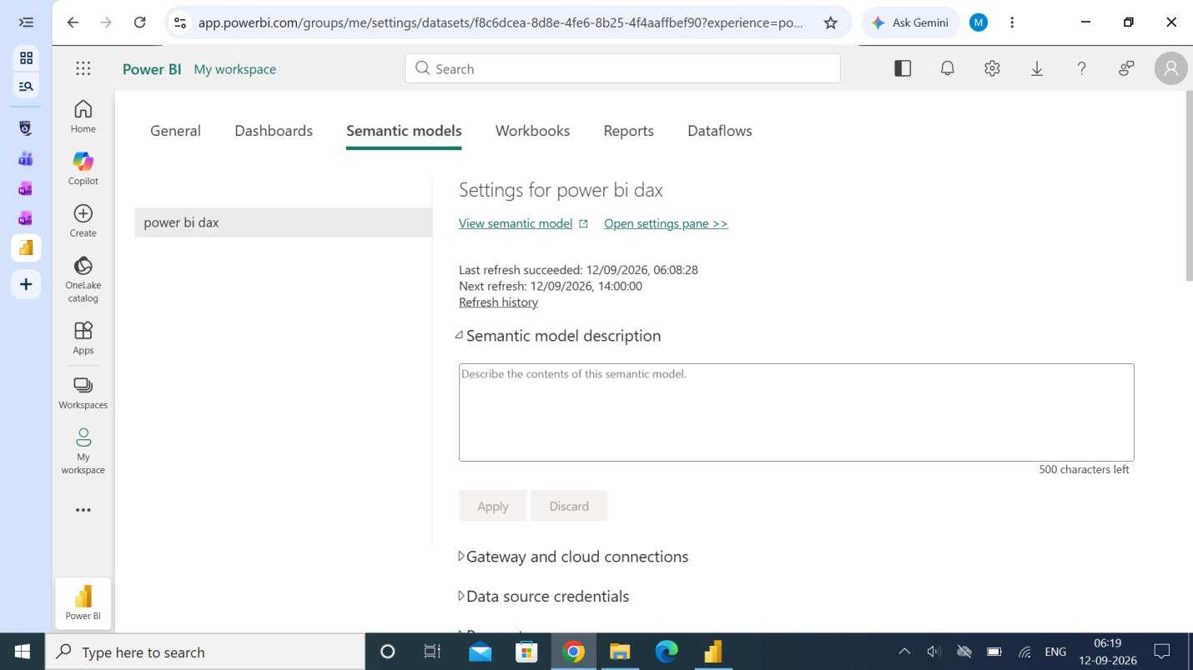

- 2. Scheduled Refresh Configuration

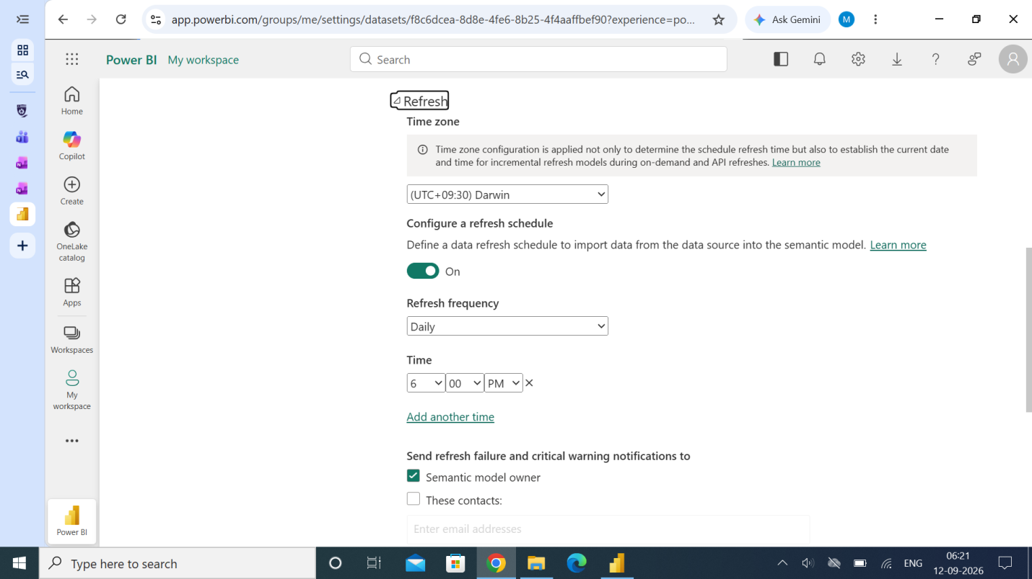

Metric calculation logic:
Total sales represents the overall sales revenue in the sample dataset. Sales by Category, Region, Quarter and Gender are calculated by grouping total sales according to each relevant category. The YTD Sales metric represents sales accumulated from the beginning of the year to the selected date. The %Change metric shows the percentage difference in sales between the relevant comparison periods. These calculations help maintainers understand how the report metrics are generated and make future updates easier.

